**PROJECTBASED LAB REPORT**

**On**

**Objective Oriented Programming**

**INFORMATION OF CITIES IN ANDHRA PRADESH**

**Submitted in partial fulfilment of the**

**Requirements for the award of the Degree of**

**Bachelor of Technology**

**In**

**ELECTRONICS AND COMMUNICATION ENGINEERING**

**By**

|  |
| --- |
| **ROHINI PANDIRI 2100031934** |

**Under the guidance of**

**Dr.K. Ravindranath**



**DEPARTMENT OF**

**ELECTRONICS AND COMMUNICATION ENGINEERING**

**K L University**

Green Fields, Vaddeswaram, Guntur District-522 502

**2016-2017**

**K L University**

**DEPARTMENT OF COMPUTER SCIENCE AND ENGINEERING**

**OBJECT ORIENTED PROGRAMMING**



***CERTIFICATE***

This is to certify that this project based lab report entitled **“INFORMATION OF CITIES IN ANDHRA PRADESH”** is a bonafidework done by **ROHINI PANDIRI 2100031934** in partial fulfillment of the requirement for the award of degree in **BACHELOR OF TECHNOLOGY** in **Electronics and Communication Engineering** during the academic year 2016-2017.

**Faculty In Charge Head of the Department**

**K L University**

**DEPARTMENT OF ELECTRONICS AND COMMUNICATION ENGINEERING**



***DECLARATION***

We hereby declare that this project based lab report entitled **“INFORMATION OF CITIES IN ANDHRA PRADESH”** has been prepared by us in partial fulfillment of the requirement for the award of degree “**BACHELOR OF TECHNOLOGY in ELECTRONICS AND COMMUNICATION ENGINEERING** ” during the academic year 2016-2017.

I also declare that this project based lab report is of our own effort and it has not been submitted to any other university for the award of any degree.

**Date:**

**Place: Vaddeswaram. By**

**ROHINI PANDIRI 2100031934**

**ACKNOWLEDGEMENTS**

My sincere thanks to **Dr.K.Ravindranth**  in the Lab for their outstanding support throughout the project for the successful completion of the work

We express our gratitude to **Dr.A.S.C.S SASTRY,** Head of the Department for ELECTRONICS AND COMMUNICATION ENGINEERING(ECE) for providing us with adequate facilities, ways and means by which we are able to complete this term paper work.

We would like to place on record the deep sense of gratitude to the honorable Vice Chancellor, K L University for providing the necessary facilities to carry the concluded term paper work.

Last but not the least, we thank all Teaching and Non-Teaching Staff of our department and especially my classmates and my friends for their support in the completion of our term paper work.

**By**

**ROHINI PANDIRI 2100031934**

**CONTENTS**

1. Introduction
2. Objectives of the system
3. Modules description
4. Source code
5. Snap shots of the output
6. Conclusion
7. References

**ABSTRACT**

The main objective of our project is **“INFORMATION OF CITIES IN ANDHRA PRADESH”**. To develop a software for customers to get all the selected city information of AP.The basic theme of the software is to provide best information of cities they selected in quick time and as accurate as possible. It provides easy approach to the end customers. Customers are provided with various options to get the details. AP State consists of 30 cities/towns across all 13 districts. The major cities include Amaravati, Vijayawada, Vizag, Chittoor, Nellore etc.

The major requirements what user wants about the city is as follows,1.Area 2.Population 3.Education facilities 4.Hospitals 5.Hotels 6.Touristplaces, 7.History etc. The system initially stores the information and when user selects city it displays information. It also to enable the user’s workspace to have additional functionalities which are not provided under this software. This project is developed to nurture the needs of a user by embedding all information at one place.

It is a application software implemented through basic Java Programming. It uses all the concepts of OOPS. It enables users to various options like "**SEARCH CITY**". The software is highly secured due to Application of java. User will get & will satisfy with the software and he can understand it very easily. In this software we will provide flexibility to easily search what the user wantsthe information of city time to time if any changes are there in the city information. The software is divided into different modules for better design and execution.

**ROHINI PANDIRI 2100031934**

**INTRODUCTION**

The main objective of our project is **“INFORMATION OF CITIES IN ANDHRA PRADESH”**. To develop a software for customers to get all the selected city information of AP. The basic theme of the software is to provide best information of cities they selected in quick time and as accurate as possible. It provides easy approach to the end customers.

There are various other sites, which provide Andhra city info, but this software is very accurate. This is one of the software’s doing same job. User satisfaction is very important. Once user get attracted, he or she will use software continuously. The city info of AP includes 7 cities and their basic information is provided to the users by the software.

**About Andhra Pradesh:**

**Andhra Pradesh** is one of the 29 [states of India](https://en.wikipedia.org/wiki/States_and_territories_of_India), situated on the southeastern coast of the country. The state is the [eighth](https://en.wikipedia.org/wiki/List_of_states_and_territories_of_India_by_area) largest state in [India](https://en.wikipedia.org/wiki/India) covering an area of 160,205 km2 (61,855 sq mi). As per [2011 census of India](https://en.wikipedia.org/wiki/2011_Census_of_India), the state is [tenth](https://en.wikipedia.org/wiki/List_of_states_and_union_territories_of_India_by_population) largest by population with 49,386,799 inhabitants. On 2 June 2014, the north-western portion of the state was bifurcated to form a new state of [Telangana](https://en.wikipedia.org/wiki/Telangana). In accordance with the [Andhra Pradesh Reorganization Act, 2014](https://en.wikipedia.org/wiki/Andhra_Pradesh_Reorganisation_Act,_2014), [Hyderabad](https://en.wikipedia.org/wiki/Hyderabad) will remain the [*de jure*](https://en.wikipedia.org/wiki/De_jure) capital of both Andhra Pradesh and [Telangana](https://en.wikipedia.org/wiki/Telangana) states for a period of time not exceeding 10 years. The new river-front proposed capital in [Guntur district](https://en.wikipedia.org/wiki/Guntur_district) is [Amaravati](https://en.wikipedia.org/wiki/Amaravati_(state_capital)), The state has a [coastline](https://en.wikipedia.org/wiki/Coastline) of 974 km (605 mi), the second longest among all the states of [India](https://en.wikipedia.org/wiki/India) after [Gujarat](https://en.wikipedia.org/wiki/Gujarat). There are two regions in the state namely [Coastal Andhra](https://en.wikipedia.org/wiki/Coastal_Andhra) and [Rayalaseema](https://en.wikipedia.org/wiki/Rayalaseema). These two regions comprise 13 districts, with 9 in Coastal Andhra and 4 in Rayalaseema.

There are total of 31 cities and towns in AP. So here it is not possible to consider all, In our project. We have considered the Major cities only.

**ROHINI PANDIRI 2100031934**

**PROJECT DESCRIPTION**

This project is based on providing city information to the end user. in this User is free to access the software. User is needed to search the city name ,he wants to get details. Then there are many sub modules like 1. Location,2. Area etc... All the basic information is merged in the program. There is one main class in which Switch case is used .There is a Get City method in which all info of cities is stored, one Menu function in which option is created to select city. There is a void city functioning which object of menu is called. All the methods are interlinked with one another.

**MODULE DECRIPTION**

**Module 1:**

City Menu: It consists of all the information of the particular city, for example Vijayawada

It contains 1. Location\n2. Population\n3. Area\n4. Famous Centers\n5.Tourist places \n6. Educational Institutions\n7. Hotels\n8. Emergency Information\n9. cinema hall info\n10. Hospitals\n11. Specialty.

It provides the user a clear-cut detail about all the facilities required in a city. It is not possible to make every minute detail of the city, so in this module we have provided all the basic information

**Module 2:**

**Get City:**

In this module, Get City the city names are assigned. There are 5 cities in this module each city is specified by get city function. There is a menu function, called by get city function. This module is nested with menu. for example, GetCity1-Vijayawada, GetCity2 etc. like this we manage the city modules.

All these are specified in AP info class, the object is created for a info class. The methods are called by the object.

**ROHINI PANDIRI 2100031934**

**Hardware Specification**

**Definition of Hardware:**

Computer hardware is the collection of physical elements that constitutes a computer system.

Computer hardware refers to the physical parts or components of a computer such as the

monitor, mouse, keyboard, computer data storage, hard drive disk (HDD), system unit (graphic

cards, sound cards, memory, motherboard and chips), etc. all of which are physical objects that

can be touched.[1] In contrast, software is instructions that can be stored and run by hardware.

Minimum Hardware Requirements for our Program:

 PROCESSOR: Pentium IV processor or Greater

 RAM: 1 Giga Byte (GB) or Greater

 HARD DISK : 100 Giga Byte (GB) or Greater

 Keyboard &amp; Mouse

 MONITOR: Colour (For Best Result)

 Printer

Minimum Software Requirements:

 Operating System: Windows 2000/ xp /7/8/10

• Java and NetBeans.

**WORKING OF THE PROJECT**

In this domain, the working of the project is very clearly explained by the given inputs and desired outputs. The working of the software depends on what inputs you are giving,

The efficiency of the software depends on the user and its time complexity.

The input is entered by the user, that is he selects the city he wants to know about. For example

Vijayawada, 1. Location\n2. Population\n3. Area\n4. Famous Centers\n5.Tourist places

\n6. Educational Institutions\n7. Hotels\n8. Emergency Information\n9. cinema hall info\n10.

Hospitals\n11. Specialty.

.

**SOURCE CODE:**

/// AP information ///

import java.io.*;

import java.util.*;

abstract class A

{

abstract void city();

}

class B extends A

{

void city()

{try{

File temp = new File("Vijayawada.txt");

Scanner file =new Scanner(temp);

while(file.hasNext()){

String s= file.nextLine().trim();

System.out.println(s);

}} catch (IOException e) {

e.printStackTrace();

}

}

}

class C extends A

{

void city()

{

try{ File temp = new File("Visakapatnam.txt");

Scanner file =new Scanner(temp);

while(file.hasNext()){

String s= file.nextLine().trim();

System.out.println(s);

}} catch (IOException e) {

e.printStackTrace();

}

}

}

class D extends A

{

void city()

{try{

File temp = new File("guntur.txt");

Scanner file =new Scanner(temp);

while(file.hasNext()){

String s= file.nextLine().trim();

System.out.println(s);

}} catch (IOException e) {

e.printStackTrace();

}

}

}

class E extends A

{

void city()

{try{

File temp = new File("kakinada.txt");

Scanner file =new Scanner(temp);

while(file.hasNext()){

String s= file.nextLine().trim();

System.out.println(s);

}} catch (IOException e) {

e.printStackTrace();

}

}

}

class F extends A

{

void city()

{try{

File temp = new File("tirupati.txt");

Scanner file =new Scanner(temp);

while(file.hasNext()){

String s= file.nextLine().trim();

System.out.println(s);

}} catch (IOException e) {

e.printStackTrace();

}

}

}

class Choice

{

int cho;

Scanner sc=new Scanner(System.in);

void choose()

{ while(true){

System.out.println("1.Vijayawada");

System.out.println("2.Visakapatnam");

System.out.println("3.Guntur");

System.out.println("4.Kakinada");

System.out.println("5.Tirupati");

System.out.println("6.Exit");

System.out.println("Enter ur choice");

cho=sc.nextInt();

switch(cho)

{

case 1:

B b=new B();

b.city();

break;

case 2:

C c=new C();

c.city();

break;

case 3:

D d=new D();

d.city();

break;

case 4:

E e=new E();

e.city();

break;

case 5:

F f=new F();

f.city();

break;

case 6: System.exit(0);

default:

System.out.println("you entered wrong number");

break;

}

} }

}

public class Apinfo

{

public static void main(String[] args)

{

Choice c=new Choice();

c.choose();

}

}

**//////////////////////////////////////////////////////////////////////////////////////////////////////////////////////**

**///File “Vijayawada.txt”///**

The population of vijayawada is 1,476,358 as per 2011

It is also known as 'The Business Capital of Andhra Pradesh

It is on bank Krishna River

It was ruled by Madhava Varma

These hills are part of the Eastern Ghats cut through by the Krishna river.

The famous centres are

1.Bhavani puram

2.Benz Circle

3.moghal raj puram

4.auto nagar

The tourists places are

1.Durga Temple

2.Gandhi Hill

3.Bhavani Island

4.Museum

5.Prakasham Barrage

The educational institutions present in vijayawada are:

1.Dr. Ntr University of Health Sciences

2.V.R.Sidhardha College of Engineering

3.Loyola collage

4.P B Siddartha

5.Westin hotel mangement

6.Narayana

7.Chaitanya colleges

The famous hotels are

1.D.V. Manor

2.Gateway

3.Fortune Murali

4.Grand minerva

5.RR Joints

6.Southern Spice

7.bawarchi.

Theatres of vijayawada are

1.inox,

2.cinepolis

3.capital cinemas

4.pvr cinemas

5.kaparthi.

The hospitals are

1.Nramesh hospital

2.Nandhra hospitals

3.Manipal hospital

4.NRI hospital

Ambulance- 108, Fire- 102, Police- 100

**///File "Visakapatnam.txt"///**

The population of Visakapatnam is 2,035,922 as per 2011

It is the most populus state in the state AP

It is also known as the Financial Capital of Andhra Pradesh

Visakhapatnam Port is the fifth busiest port in India in terms of cargo handled.

Visakhapatnam is home to the oldest shipyard and the only natural harbour on the east coast of India

These hills are part of the Eastern Ghats cut through by the Krishna river.

It is known as goa of east

It was ruled by the Vengi kingdom, the Pallava and Eastern Ganga dynasties.

The the famous centres

1.Gajuwak

2.Seethamadhara

3.Dwaraaka busstand

4.RK beach

5.kailasgiri.

The tourist spots are

1.Rk beach

2.Dolphin hills

3.Rishi konda beach

4.Vishaka steel plant

5.stadium

6.Araku valley

The institutions present are

1.Andhra university

2.GITAM university

3.Vignan's college of engg.

The hotels are

1.Vajrams

2.Grand minerva

3.Venkatesh Grand.

The Theatres are

1.Sai movies

2.Prasdas imax

3.PVR cinemas

4.Hollywood

The Hospitals are

1.Appolo

2.kims

3.lb prasd eye institute

The Ambulance- 108, Fire- 102, Police- 100

**///File “guntur.txt”///**

"The population of Guntur is 743,354 as per 2011

It is also the mandal headquarters of Guntur mandal in Guntur revenue division

The city is the second largest by area and third most populous in the state.

It exports chilli pepper, cotton,tobacco

The Guntur is having asia's biggest mirchi yard2.It is very famous for chillies.

Agastyeshwara temple is one of the famous temples in the city."

The famous centres are

1.Jinnah Tower

2.Naaz Centre

3.brodipet

4.busstand.

The tourist places

1.Naaz Centre

2.Gandhi Park

3.Manassarovaram Park

The Institutions preset are

1.K L University

2.RVR&JC College of Engineering

3.Acharya Nagarjuna University

4.KHIT

5.Vignan versity

Thefamous hotels

1.Vajrams

2.Grand Nagarjuna

3.Venkatesh Grand

4.Shankar Vilas

TheTheatres are

1.Harirar

2.Cine square

3.pallavi

4.Siva

5.Naazdeluxe

6.Hollywood

The hospitals

1.KIMS

2.sims institute

3.NRI hospita

TheAmbulance- 108, Fire- 102, Police- 100

**///File "kakinada.txt"///**

The population of Kakinada is 312,538 as per 2011

Kakinada has been selected as one of the hundred Indian cities to be developed as a smart city under PM Narendra Modi's flagship Smart Cities Mission

Kakinandivada, a village near the present Kakinada was a Dutch settlement.

They also used to store and export Coconut products and, hence, the name Co–canada.

Some theories suggest Kakasura's losing his eye by an arrow of Lord Rama gave the name Kakinada

The famous centres are

1.Arundelpet

2.Singh tower

3.Kakinada port

4.auto nagar

5.Beach centre

The tourists places are

1.Coringa Sanctuary

2.Bhimesvara Temple

3.Kakinada harbour

The educational institutions in Kakinada are

1.Rangaraya Medical College

2.JNTU-K

3.Master Minds College

4.PSR Law College

5.Narayana &Chaitanya colleges

The famous hotels are

1.Royal Park

2.Balaji Grand

3.GRT Hotels

4.Hotel sasi Inn

5.Minerva

The Theatres are

1.Priya Cinemas mini Multiplex

2. Veer kamal Theatre

3.PVR cinemas

4.Satya gowri theatre

The hospitals are

1.ramesh hospital

2.Apollo

3.KakinadaNayana Eye Care

4.GGH Trust Hospital

Ambulance- 108, Fire- 102, Police- 100

**///File “tirupati.txt”///**

The population of Tirupati is 287,482 as per 2011

Tirupati has been selected as one of the hundred Indian cities to be developed as a smart city

Tirupati is considered one of the holiest Hindu pilgrimage sites because of Tirumala Venkateswara Temple,

besides other historical temples, and is referred to as the 'Spiritual Capital of Andhra Pradesh'

Sri Venkateswara National Park is a national park and biosphere reserve which is part of Seshachalam Hills

It is the Asia's Second largest Zoo with an area of 5500 acres.

The famous centres are

1.Alipiri marg

2.Ntr circle

3.SV centre

4.auto nagar

The tourists places are

1.deer park

2.Tirumala Iskon temple

3.Kapiltheerdh

4.SVUniversity

The educational institutions present in Tirupathi are

1.S V University

2.IIT Tirupathi

3.PBSiddartha

4.IISER

5.Tirupathi Narayana & Chaitanya colleges

The famous hotels are

1.Gateway

2.Andhra Spice

3.Blue Fox

4.Vanam Restaurant

5.Minerva Coffee Shop

Theatres of Tirupathi are

1.GVCinemas

2.Jayram Group Theatre

3.PVR cinemas

4.kaparthi

5.V V Mahal

The hospitals are

1.Ramesh hospital

2.Gayatri hospitls

3.Maha hospital.

Ambulance- 108, Fire- 102, Police- 100

**SNAP SHOTS OF OUTPUT**

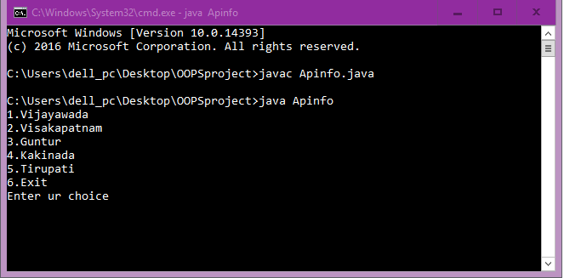

**<<<Entered wrong choice>>>**

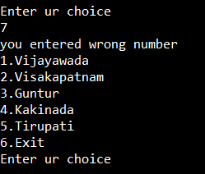

**<<<Vijayawada>>>**

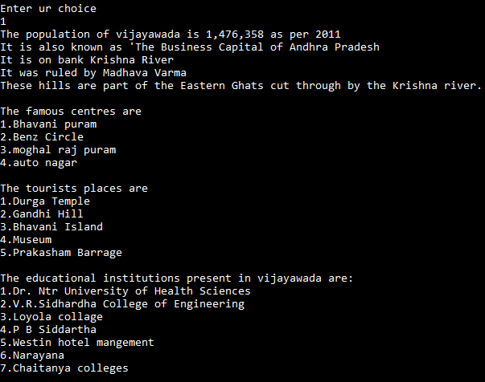

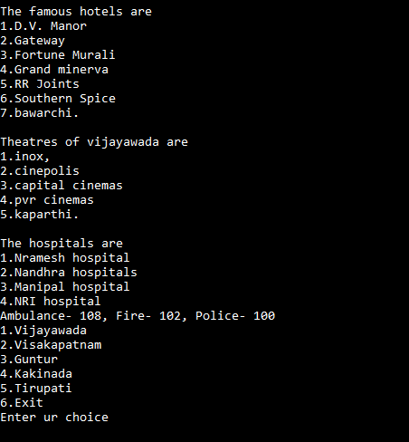

**<<< Visakhapatnam >>>**

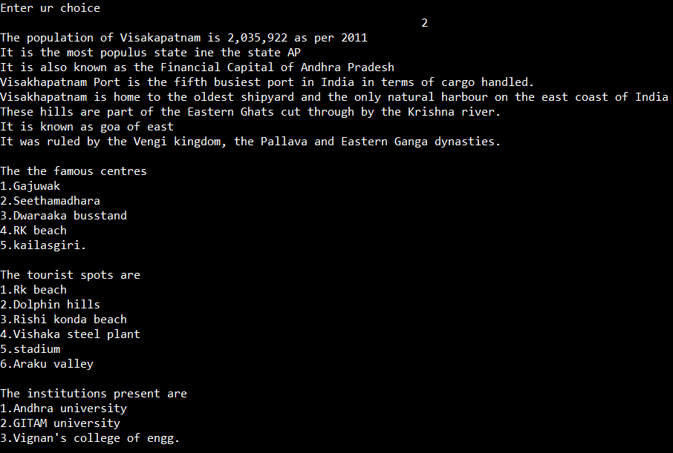

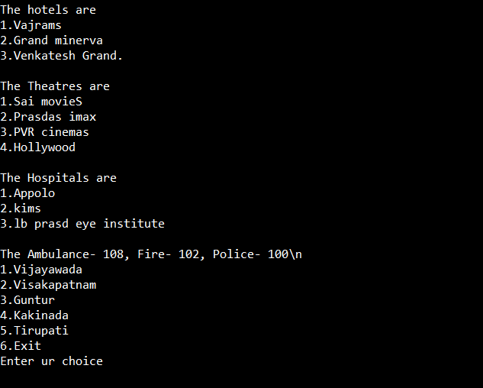

**<<< Gunturu>>>**

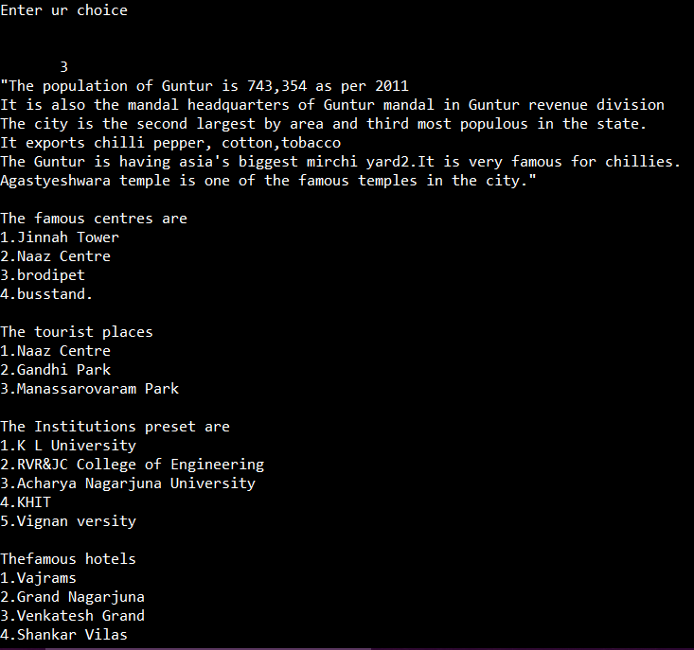

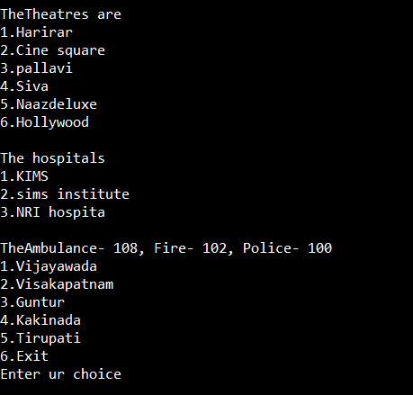

**<<< Kakinada>>>**

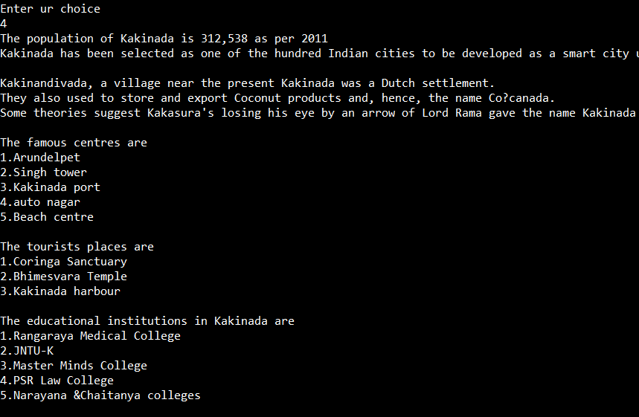

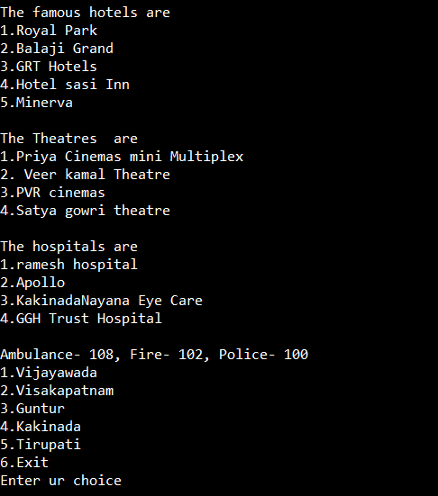

**<<< Tirupathi>>>**

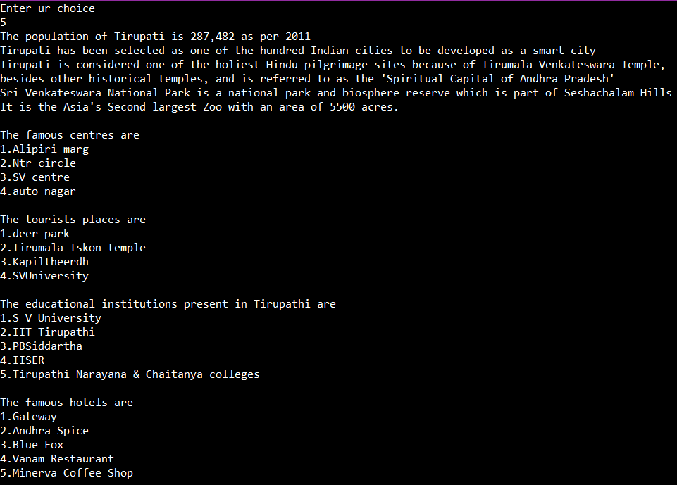

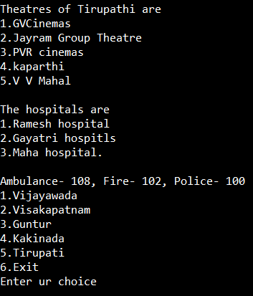

**CONCLUSION**

Here in this project, we can include many modules, functions & flavors you want. We have done this project through java source by using switch case concept, object creation, calling functions etc. We can develop it through many ways. The project on AP cities provide a good and clean info on availability of different facilities of the cities. This project mainly concentrates on user requirements. This system is easy to use We hope that we have done our best to complete this project

**REFERENCES**

1. Herbert Schildt, “The Complete Reference Java2”, 5th edition TMH, 2002.

2. Timothy A. Budd, “An Introduction to Object-Oriented Programming”, 3/E, Pearson, 2008.

3. Jim Keogh, “The Complete Reference J2EE”, TMH, 2006.

4. Deitel &amp; Deitel, “‘JAVA – How to program”, 6th edition, PHI, 2007.

5. https://www.cs.utexas.edu/~scottm/cs307/codingSamples.htm

.